

**Master of Science Thesis**

**Mid-term Review**

**Multi Energy Systems:**

Assessing energy flexibility in industrial parks using multi energy modelling

**Thesis Project Name:** Investigating Hidden Flexibilities Provided by Power-to-X Considering Grid Support Strategies

**MSc. Student:** Bekir Caner Yagci (4857089)  
**PhD:** Digvijay Gusain  
**Thesis Supervisor:** Asst. Prof. Milos Cvetkovic

**Version Control:** <https://github.com/caneryagci/Multi-Energy-Systems-Thesis-Project.git>

Table of Contents

1. Research Problem 3

2. Flexibility 3

3. Research Questions 4

4. Methodology 4

4.1 OpenModelica 4

4.2 Co-Simulation & Energysim 5

4.3 Hierarchical Control 7

4.4 Optimum Demand Side Management of Flexibility 8

4.5 Hypothetical Maasvlakte 2 Energy Park (Microgrid with AC feeder) 10

4.6 Historical Data Processing & Probabilistic Weather 11

5. Modelling 12

5.1 Renewable Energy Sources 12

5.1.1 Wind Turbine Generator 12

5.1.2 PV Farm 13

5.2 External Grid and Optimal Power Flow 14

5.3 Industrial Loads 14

5.3.1 Power-to-Gas 14

5.3.2 Power-to-Heat 16

5.3.3 Electrical Base Load 16

6. Co-Simulation Scenarios 16

6.1 First case 16

6.2 Second case 16

6.3 Third case 16

7. Inıtial Results 16

8. Future Plans 17

References 19

# Research Problem

Eternal objective of power system operators have been balancing the supply-demand mismatch. With increasing share of renewable energy (RE), this mission became more challenging. Power balance is regulated by curtailment of renewable energy sources (RES) in power systems, but curtailment also means loss of electricity. It can be reduced if overall power system flexibility is increased. Replacing production based on fossil fuels (e.g. thermal heating process, grey hydrogen, methanation) in many industries, such as chemicals, petrochemicals, food, steel cement, glass; large-scale electrification makes the industrial complex more sustainable and provides the necessary flexibility and stability in the new energy system [25,26]. Multi energy systems (MES), where different energy carriers interact at lower system levels, is proved to provide this flexibility (and reduce curtailment) by combining various energy domains with Power-to-X (P2X). Thus, energy systems need better perception of flexibility of P2X technologies during the operation.

Most of the research available in the literature for multi-energy system analysis, develop simple generic models or linearized models in order to reduce the computational burden and the modelling complexity. Due to these approximations made in model formulations, flexibilities provided by MES components to the network can be concealed in the simulation results. As follows, in this project, hidden flexibility defined as the flexibility that is disappeared/generated in the simulation results due to model simplifications.

Considering flexibility key figures (activation, holding and restore time), detailed modelling of ramp-up/down time and efficiency under different operating conditions of such systems are critical to understand the hidden flexible capacity of such systems. For grid operators and industrial P2X owners, it is of great importance to know the exact amount of flexible capability of such systems. Inaccurate flexibility analysis of P2X may lead to increased transmission losses, higher operational cost or misinterpretation of MES capacity.

Many of the existing research available in the literature for hierarchical management of energy in MES only provide information about the excess and shortage amounts of energy to the community energy management system (CEMS) at each time interval. CEMS only optimizes this amount from individual components. Each component does not have any information about the energy cost of other MES component of the network. This approach results in unnecessary trading of electricity with the utility grid and causes an increase in operational cost of P2X owners [21].

Even though several flexible loads involve in an industrial process, they are mainly considered as isolated flexible loads. However, in reality, it cannot be assumed that a flexible load is always isolated. In a multi energy system, dependencies between flexible loads must be investigated. The dependency can describe that flexible load “X” requires the usage of flexible load “Y” sometime in advance. In other words, usage of any of the flexible load measures poses some constraint on the usage of the other flexible load, another example can be to reduce operational cost or to avoid consumption peak. Hierarchical Control of a MES with flexible loads requires such consideration in flexibility decision making in order to have more in depth understanding of flexibility of P2X [15].

# Flexibility

In this project, flexibility defined as, the ability of a component or a collection of components to response challenges caused by power fluctuations in energy systems.During excess RE, this response can be achieved by flexible P2X, as the amount of consumed energy can be increased to higher load state. Change from their constant values for a specific holding duration provides power balance during excess RE and reduces operational costs for P2X owners by shifting load to time of low electricity prices.

From an operational perspective, P2X flexibility becomes relevant in situations where there is excess RE supply relative to demand in the power system and, therefore, electricity prices decrease. When the flexibility is “off”, demand follows the pre-defined load profiles (output flow rates) at constant storage pressure and temperature. Changing the storage tank energy capacity, when the flexibility is “on”, will accelerate the electrical power consumption of power-to-gas (P2G) and power-to-heat (P2H) to the nominal values or to a specific power state coming from CEMS.

The key figures that characterize flexibility are activation duration (tact), holding duration (tflex,on), the amount of power (capacity) and deactivation period (trestore)[15]. Activation duration , that is the amount of time to reach flexibility setpoint, and deactivation period, the amount of time to return to base set point, will be decided based on thermal and gas inertia of P2H and P2G system respectively.

# Research Questions

* What options exist for minimizing curtailment of renewables in MES?
  + Which options are available in industrial area?
  + How much profit P2X owners can make from shifting demand to low price times?
* How much model detail impacts the flexibility analysis?
  + What should be the detail of a model (heat pump, electrolyser) for desired MES analysis?
* What is the optimal deployment of flexibility in order to reduce operational cost for P2X owner?
  + What should be the control architecture of MES?
  + How can different energy domains can be combined and optimized for flexibility?
  + What are the dependencies between flexible load pairs?

# Methodology

## **OpenModelica**

Modelica is an object-oriented, equation-based programming language which allows for dynamic simulations of multi-domain systems [24]. By reason of Modelica allows a physically based, dynamic simulation of the dynamic reactions; disturbances can be modelled and assessed. It allows the combination of models coming from different technical domains in a unified way. Acasual modelling of Modelica provides effortless modelling and fast simulation of complex dynamics. Thus, Modelica language is suitable to simulate coupled energy systems with different levels of detail.

Various OpenModelica (OM) libraries, such as PowerGrids, PowerSystems, PVSystems, WindPowerPlants, AixLib, Buildings etc, have been considered in order to find the optimum balance between the simulation computation time, modelling simplicity and resolution of results. The controller models of PVSystems Library [16] has found useful for grid support analysis, but comes with increasing computation time threshold. As a result, iTesla Power Systems Library (iPSL) [14] has decided to be the best option for the desired amount of simulation time and level of detail.

MES components with first order dynamics and active power, reactive power, voltage control is modelled in OM for each MES agent as illustrated in Fig.8, 9, 10. These models can be further improved for faster or more detailed control and flexibility analysis of MES.

Besides, P2X and RES modelled in object oriented Modelica Language, electrical network is modelled using PandaPower [8] as illustrated in Fig.6 and optimal power flow (OPF) is initiated. In a general manner, results of OPF are the inputs of the Modelica models as can be seen in fig.1.

## **Co-Simulation & Energysim**

To evaluate the flexibility available from P2X and the impact they can have on the electrical grid, complex simulations need to be set up [17]. Co-simulation is used for such complex system in order to implement hierarchical control, reduce computational burden and couple different energy domains. It allows complex control and flexibility analysis with multiple agents and a higher control level.

There exist many co-simulation tools for MES that allow coupling of models from various energy domains, each with their pros and cons. Energysim (previously, FMUWorld) [17] is used for co-simulation. It is a python-based tool that was developed specifically to simplify energy system based co-simulations and focus on analysis by conceptualising the setup. It allows users to combine:

* Dynamic models packaged as Functional Mockup Units (FMUs)
* Pandapower Networks packaged as pickle files
* PyPSA models (BETA) packaged as Excel workbook
* csv data files

The models are tested on OpenModelica (OM) and exported as FMUs using inbuilt FMU Export function. Models, their inputs/outputs and simulation start time for simulation case 1 &2 is illustrated in fig.2 (Detailed version for case 3 is fig.3). There are no results from this part yet. Therefore, exact step, exchange and total time is not known. However, considering the flexibilities that will be provided and the simulation time results from OpenModelica models, total duration have to be more than 5-7 hours (target: 24 hours) with 5-15 minutes exchange time.

* Simulation duration: 3600*7 (s)
* Exchange time: 120 (s)
* Step time windfarm: 3 (s)
* Step time PV: 3 (s)
* Step time P2G: 6 (s)
* Step time P2H: 6 (s)
* Step time pandapower:3 (s)

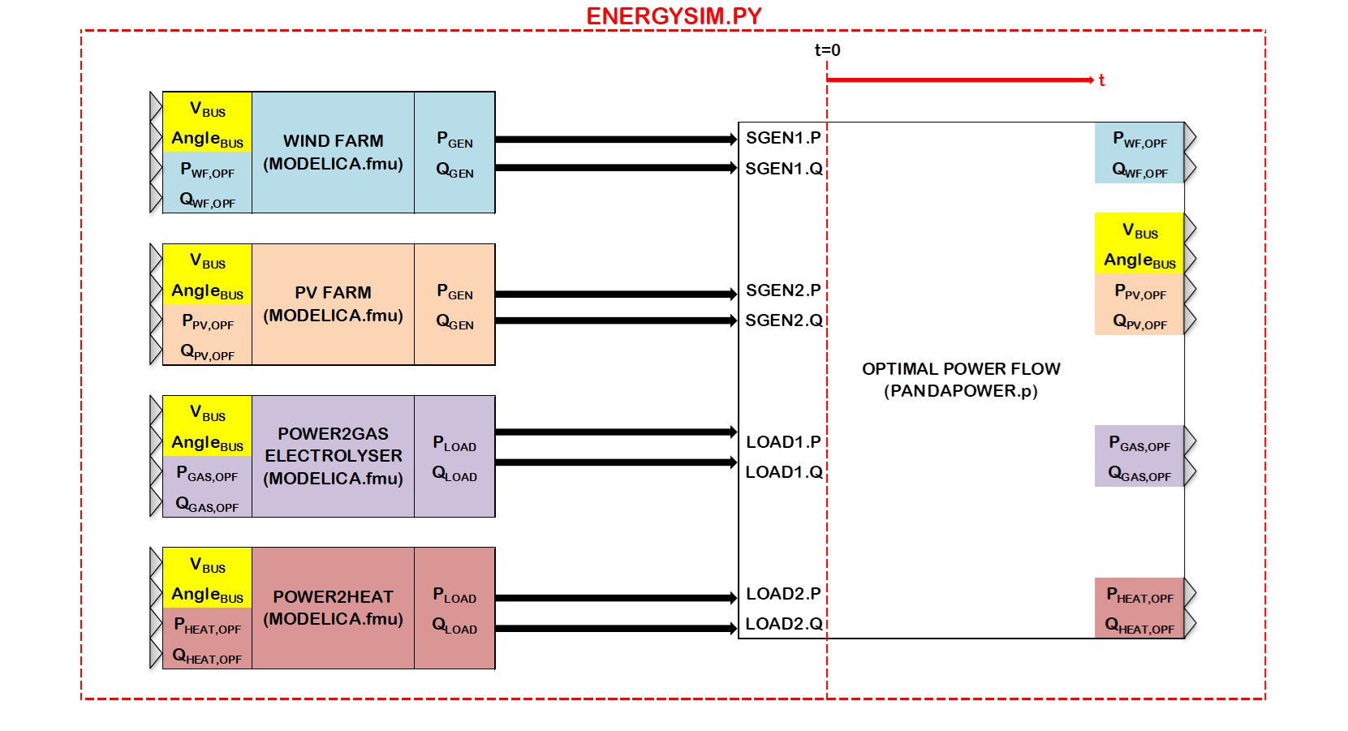

Fig.1 General co-simulation methodology

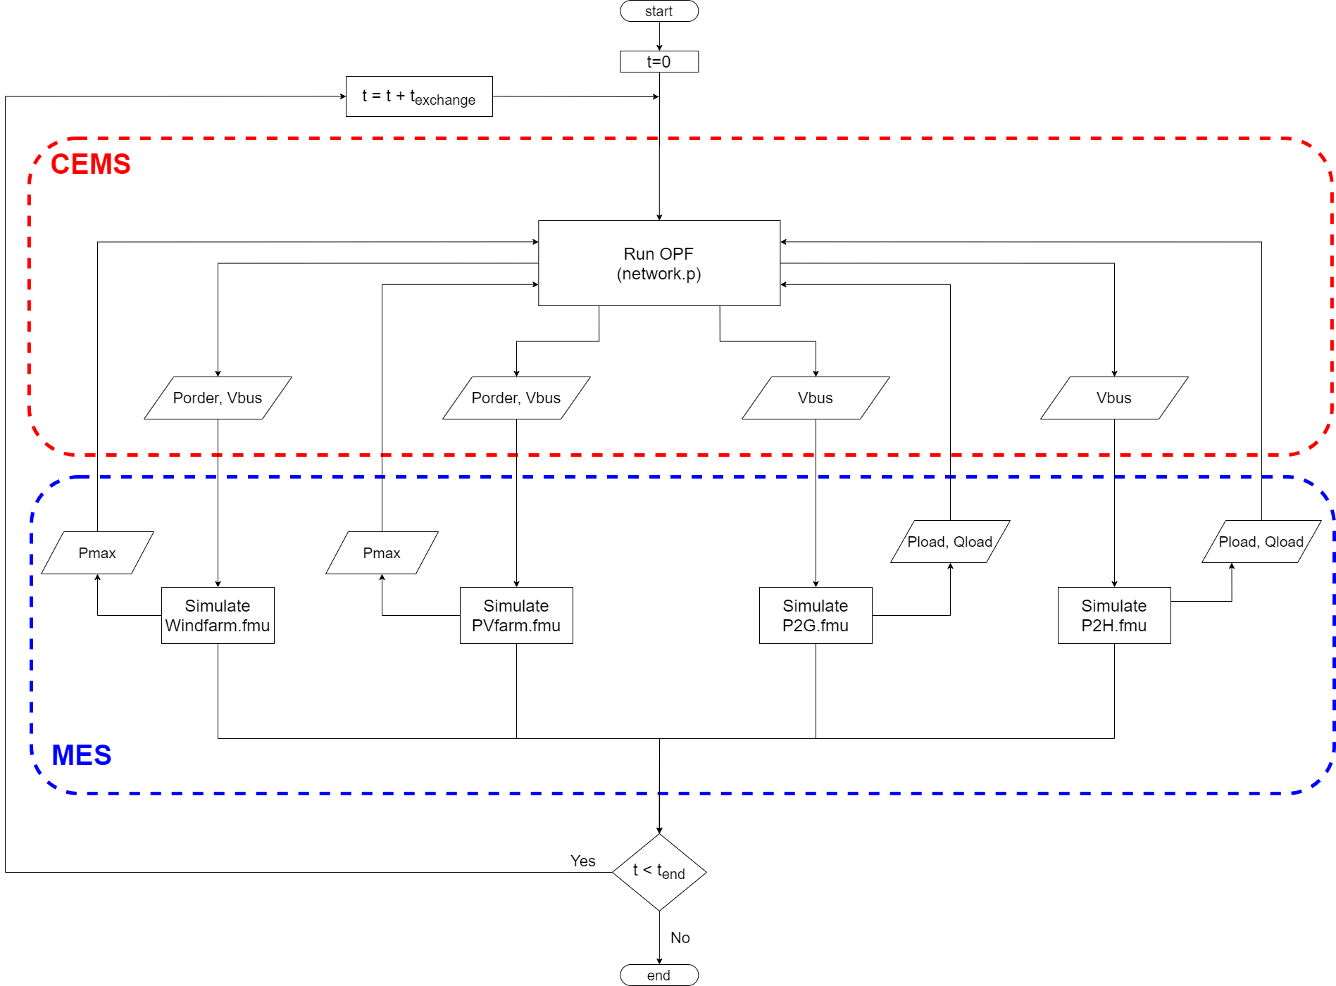

Fig.2 Co-simulation flowchart for case 1 & 2

## **Hierarchical Control**

[27] suggests that, a good combination of Market DR (price signals) and Physical DR (grid management) is necessary to run a network optimal. To have the most cost-effective operation of MES, a higher control level that interrogate the information coming from each MES agent and decide new set points is fundamental. Thus, hierarchical control is implemented for global optimization with comprehensive energy system approach. A detailed control flow chart can be seen in fig.3. Using co-simulation, more advanced control with MILP problems can be implemented in the future.

Pandapower optimal power flow results are used for the initialization of each sequence and updated with OM simulation results as illustrated in fig.2 & 3. Primary concern in industrial operations is cost. Therefore, at higher control level (CEMS, PandaPower); heat, gas intraday market prices are considered to find the optimum flexibility deployment as illustrated in fig.3. The objective of the global control is to minimize the operational cost while providing flexibility.

Details of the hierarchical control with Market DR and Physical DR is given in the next section.

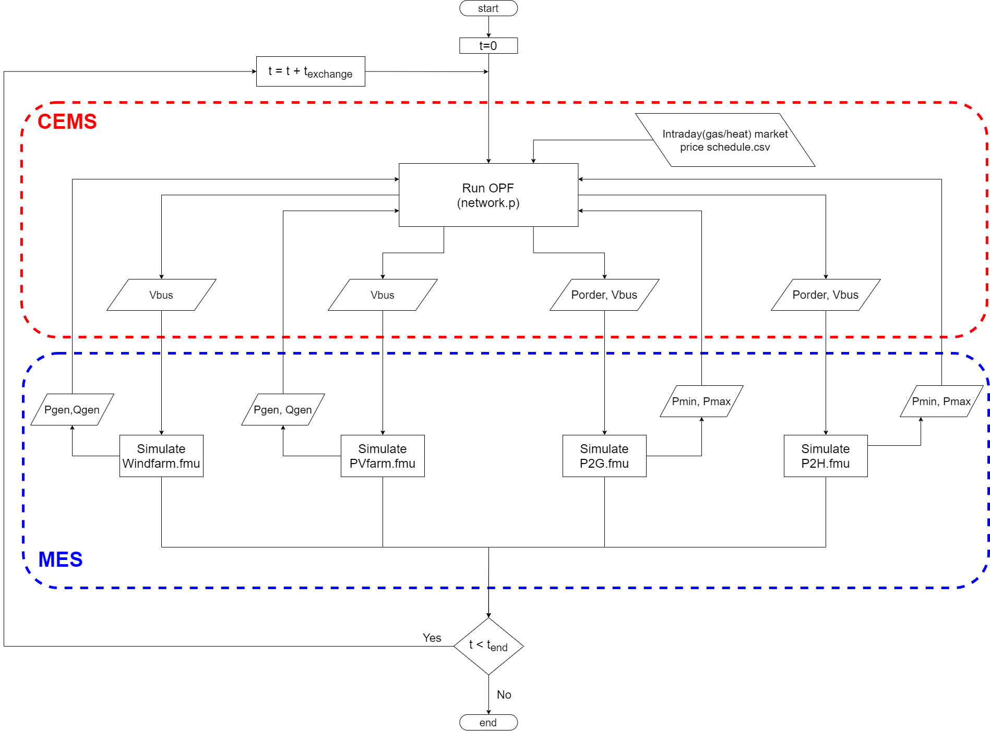

Fig.3 Hierarchical DSM flowchart for case 3

## **Optimum Demand Side Management of Flexibility**

In this project, optimization defined as finding the most cost-effective active power demands for flexibility provision (maximizing the storage during excess RE) and minimizing operational energy cost by load shifting.

Modelica (MES) agents calculate the available range of active power demand considering the available energy level of the storage and send this information to CEMS. Pmin is controlled such that demand is always satisfied. However, when the energy storage is full, electrolyser is forced to work under 10% load for a predefined time. Pmax is 1 p.u. when there is an available space in energy storage; however, it strictly follows Pmin, for a predefined time, when the storage is full. For RES models, Pmax is calculated considering the available windspeed and solar irradiation in the area at that time. Figure below illustrates the inputs and outputs of the controller block inside P2X functional mock-up units (FMU). Constraints for the decision making are also given in the formulation part.

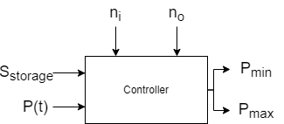

Fig.4 Controller block of P2X model

After agents sent allowable active power ranges to the network, Pandapower solves the optimal power flow with the cost functions, for the exact active power order of P2X within the allowable range defined by the agents. For P2G, historical intraday hydrogen/natural gas market prices (€/MWh), and for P2H, historical intraday heat market prices (€/MWh) will be considered. During excess RE, electricity price is assumed to be the cheapest; however, intraday electricity market prices can also be added for more detailed analysis. After running the optimal power flow, calculated active power order is sent to P2X (Direct Load Control).

**Formulation of the optimization problem**

**Global objective**: is to minimize the total energy consumption cost. Objective function runs in Pandapower [8] with polynomial cost function. Piecewise linear cost function can also be used in Pandapower; however, polynomial cost function with linear cost per MW is the most convenient option to input static (scheduled) intraday price signals during co-simulation.

**Objective Function:**

$$min\sum_{i ϵ sgen, load,ext_grid}{f_{i}\left(P_{i}\right)}$$

*subject to*

*load flow equations  
branch constraints  
bus constraints  
operational power constraints*

$$Pmin≤Porder≤Pmax, Porder ϵ P2X.p$$

$$Vmin≤V≤Vmax, V ϵ bus.p$$

**Polynomial cost function: $$f_{pol}\left(p\right)=c_{n}p^{n}+…+c_{1}p+c_{0}$$**

$f_{pol}\left(q\right)=c_{2}q^{2}+c_{1}q+c_{0}$

**Local objective:** to supply gas/heat demand at all time. PID controller follows demand change to calculate Pmin. Pmax depends on available storage capacity.

**Constraints:**

$$Pmax=\left\{\begin{aligned}1 pu, &S_{storage}≤S_{max} \\ Pmin, &S_{storage}>S_{max}\end{aligned}\right.$$

$$Pmin=\left\{\begin{aligned}u(t), &S_{storage}≤S_{max} \\ 0.1 P_{nom}, &S_{storage}>S_{max}\end{aligned}\right.$$

$$Reference(∆\dot{n})=\left\{\begin{aligned}0, &{0.5 S}_{max}≤S_{storage} \\ 0.1, &{0.5 S}_{max}>S_{storage}\end{aligned}\right.$$

Figure below illustrates the inputs and outputs of the energy balance controller for Pmin calculation. At constant temperature and pressure energy level of a storage tank can be calculated by the available volume. Reference value, shown below, is kept at “0” (ni-no=0) if storage energy level is higher than or equal to 0.5p.u. To keep the energy storage at least at 0.5p.u, reference is set to 10% if storage capacity drops below 0.5p.u.

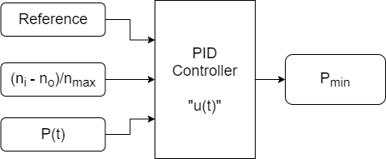

Fig.5 Generation/demand balance controller for Pmin calculation

## **Hypothetical Maasvlakte 2 Energy Park (Microgrid with AC feeder)**

In [22] it is concluded that, a combination of P2G with electric heat pumps or combined cycle gas turbines has the best cost performance in a MES with renewables. Considering the performance results of various 100% renewable MES configuration from [22] and online available news about Port of Rotterdam, a hypothetical Maasvlakte 2 Energy Park, shown in fig.6, is designed for the case study.

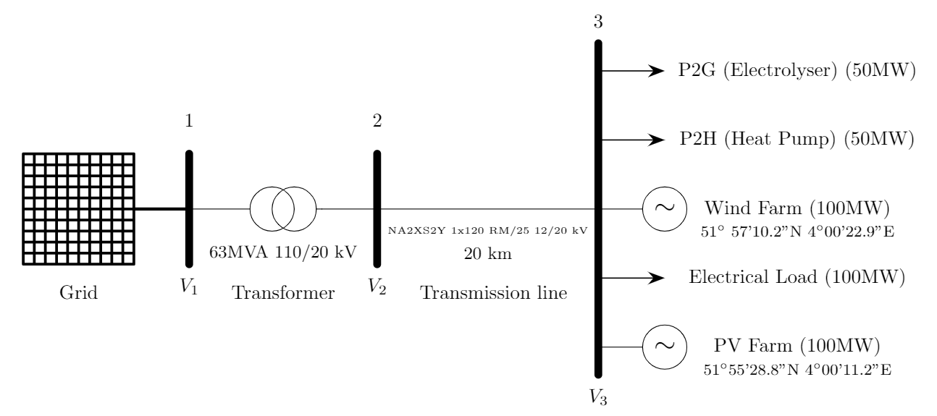

Fig.6 Considered Pandapower network

*“The outer contour of the Maasvlakte is an important location within the port area for achieving sustainable energy ambitions of the province of South Holland, the municipality of Rotterdam, the Port of Rotterdam Authority and the national government. The Covenant Agreement for the Realization of Wind Energy in the Port of Rotterdam (2009) states that by 2020 at least 150 MW of new wind capacity must be installed in the public port area. This brings the total capacity, new and existing turbines, in the port area to 300 MW [4]”*

Windfarm details in port area are given below:

* Coordinates: 51°57'10.2"N 4°00'22.9"E
* Wind Turbine Generator: GE, 3.6MW, DFIG
* Number of wind turbines: 10 (3MW) (Harde Zeewering) + 26(3MW) (Zachte Zeewering)
* Capacity: 108 MW

*“The floating solar park must be located on the Slufter, a depot for contaminated sediment of approximately 250 ha on the Maasvlakte. The westernmost location of the Slufter dredging spoil depot makes it one of the sunniest spots in the Netherlands. It is an ideal place for the generation of solar energy. It is estimated that it is possible to make approximately 100 ha of water surface available for the construction of a floating solar park, which could potentially deliver a capacity of approximately 100 MWp; accounts for the annual power consumption of approximately 33,000 households. This would make 'Zon op de Slufter' by far the largest floating solar park in the Netherlands [7].”*

PV Farm details are given below:

* Coordinates: 51°55'28.8"N 4°00'11.2"E
* PV Panel: 250 Wp
* Number of panels: 180.000<x<540.000
* Capacity: 45-135 MWp (apprx:100 MWp)

*“The high-temperature residual heat is transported from the port of Rotterdam via a pumping station powered by electricity. The heating is transported to heating centrals in Leiden, where it is dispersed to the already existing district heating network [5].”*

*“BP, Nouryon (formerly AkzoNobel Specialty Chemicals) and the Port of Rotterdam Authority are jointly investigating the possibilities of producing green hydrogen for the BP refinery in Rotterdam. Green hydrogen is produced by electrolysis of water using green power. Large-scale production of green hydrogen requires huge amounts of green electricity, for example from offshore wind farms, in addition to a very high electrolysing capacity [6].”*

Size of industrial loads will be decided in megawatt according to the measured generation capacity. Fig.6 illustrates the industrial multi energy system with AC feeder that is assumed as “Energy Park in Maasvlakte”.

## **Historical Data Processing & Probabilistic Weather**

Historical data process is summarized in the figure below. 2019 historical windspeed and solar irradiation data of Port of Rotterdam will be divided into 8 regions that is consist of 45 days. For every hour of each 45 day group a histogram will be created to calculate Weibull or Beta PDF parameters [19]. Later, this parameters will be the input via CombiTimeTables.

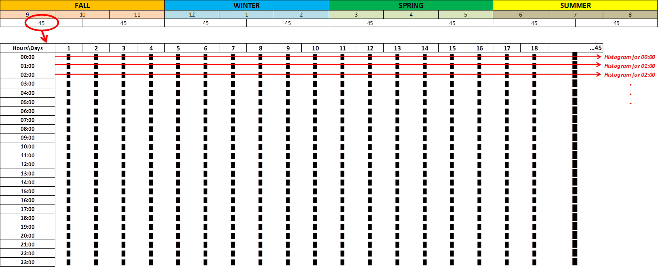

Fig.7 Histogram generation for PDF parameters

It is considered that Probabilistic Density Function (PDF) of Weibull and Beta for windspeed and solar irradiation generation respectively will be modelled based on historical data processing and the effect on renewable energy generations will be observed. (Probabilistic vs. Historical data) However, this type of simulation requires simulation duration for months and, during the modelling phase, it is observed that these models increases the simulation time significantly with the increased number of equations. Therefore, due to high computation time these models currently not in use. This part is not one of the main focuses of the project anymore, but same task can be implemented as pre-work in MATLAB and the resulting (minute or hourly) windspeed and solar irradiation data can be input as .txt to FMU’s.

* Weibull probabilistic distribution function is used for wind speed estimation. First, histogram tables will be created via historical data. Then parameters of the Weibull PDF (shape, scale) are calculated by curve fitting in MATLAB. Finally, Text files are created for hourly shape, scale parameters in “CombiTimeTable”.
* Beta probabilistic distribution function is used for solar irradiance estimation. First histogram tables will be created via historical data. Then parameters of the Beta PDF (shape, scale) are calculated by curve fitting in MATLAB. Finally, Text files are created for hourly shape, scale parameters in “CombiTimeTable”.

# Modelling

## **Renewable Energy Sources**

### Wind Turbine Generator

3.6 MW DFIG_GE_Type3 wind turbine generator is modified from iPSL Library according to [12]. Behaviour of the model is that of a current controlled voltage source converter. Turbine model converts mechanical power coming from wind into AC power order considering power produced by generator. Electrical Control commands the active and reactive power generated based on the power system conditions and turbine model. Generator provides interface between the controller and network. It includes no mechanical state variables for the machine which included in the rotor model. Also, electrical state variables are reduced to their algebraic equivalents [12]. The net result is an algebraic, controlled current source that injects the active and reactive power specified by the WTG electrical control model into the network. Finally, the output of the generator is connected to Point of Common Coupling (PCC) via PV, PQ buses and transformer as illustrated in Fig.8.

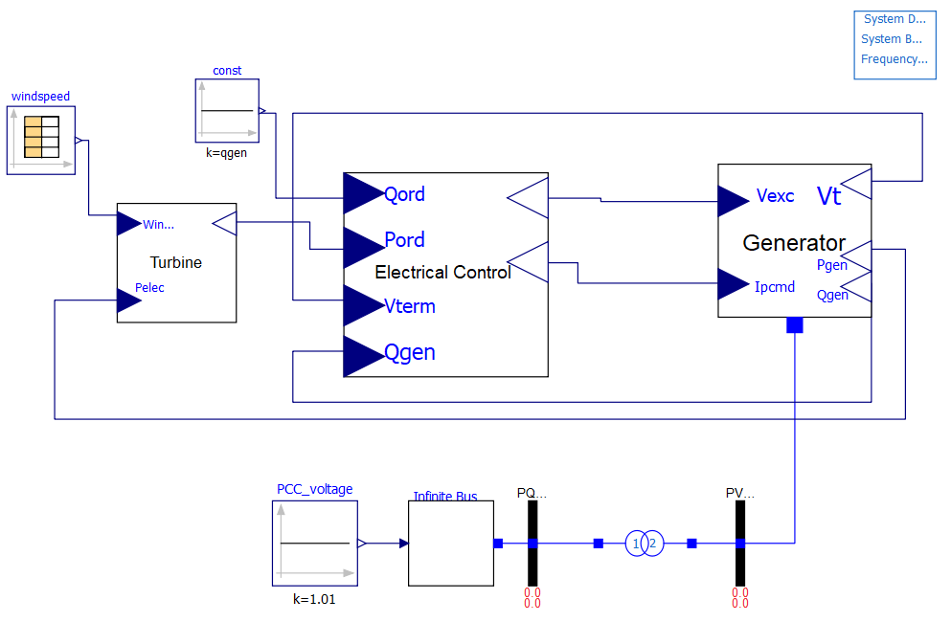

Fig.8 Wind Turbine Generator model

### PV Farm

PV Farm model from iPSL_Solar_KTH is modified according to [13]. PV block calculates cell/array current and voltage using solar irradiation, temperature and panel datasheet parameters. Also, controls DC bus voltage. DC busbar takes AC power as input to calculate new cell current and voltage. Controller calculates the active and reactive power that will be injected to the network considering system conditions. StaticGenerator provides the connection to the network. Finally, the output of the static generator is connected to Point of Common Coupling (PCC) via PV, PQ buses and transformer as illustrated in Fig.9.

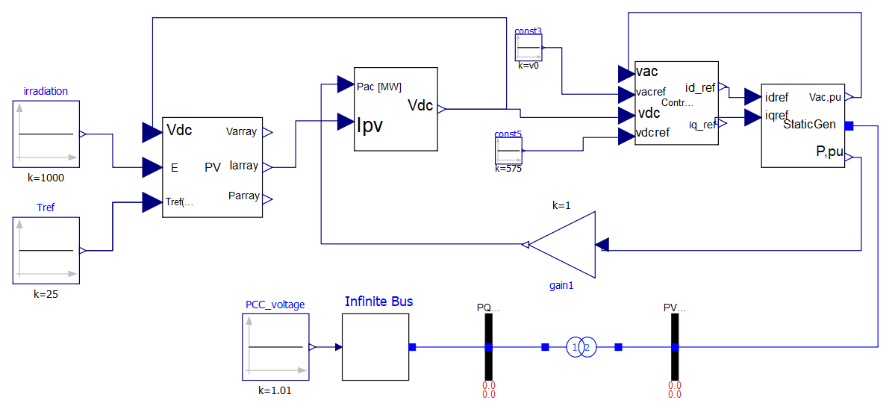

Fig.9 PV Farm model

## **External Grid and Optimal Power Flow**

External grid is modelled and optimal power flow is carried by Pandapower[8] as illustrated in Fig.6. Pandapower.py file and rest of the simulation models can be found in Github repository shared on the cover page.

## **Industrial Loads**

### Power-to-Gas

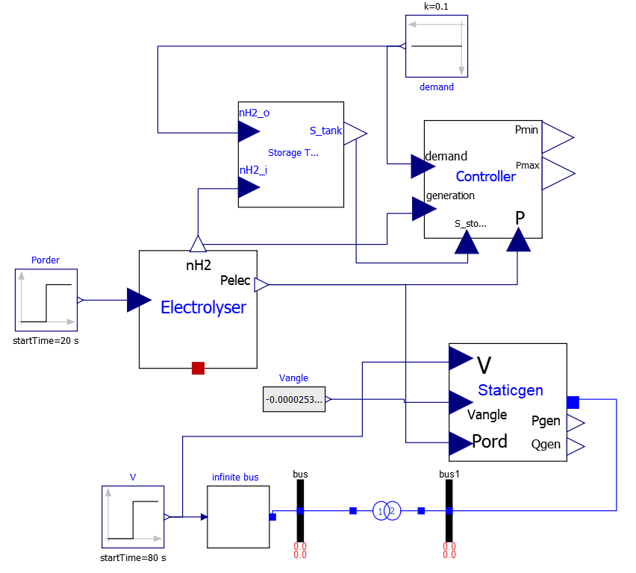

Fig.10 Power-to-Gas model

Storage tank, Compressed Gas Energy Storage (CGES), is modelled considering [11]. Pressure inside the tank is modelled as the integral of the difference between the input and output hydrogen molar flow rates, temperature and volume. Energy level of the tank can be calculated from the available volume if the tank pressure and temperature is assumed constant. However, model still needs improvements such as addition of losses. Electrolyser is modelled considering [9, 10]. It takes active power order input in order to calculate the power consumed (efficiency) and the hydrogen flow rate. Static Generator models are similar to PV Farm model and controller model is explained in section 4.4 in detail. Finally, the output of the static generator is connected to Point of Common Coupling (PCC) via PV, PQ buses and transformer as illustrated in Fig.10.

#### **Electrolyser Model:**

Comparing with fuel cell systems, limited electrolysis model develop input-output models suited for control and flexibility analysis [18]. The existing generic electrolyser models use an efficiency curve to simulate the transformation of energy from power to gas. Thus, a lot of effort has to be performed in the modelling of control design of such systems. New model is used to study the performance behaviour of electrolyser under different operating conditions. An electrochemical steady-state model is created to predict the stack voltage and the stack temperature evolution from instantaneous operating conditions such as the applied current, the gas storage pressure tanks (H2 and O2) and the ambient temperature. Temperature dynamics is added for detailed model version in order to compare the efficiency and performance behaviour of electrolyser model under different modelling assumptions.

**Simple model:** linearized equations for cell voltage calculation  
**Detailed model:** first order dynamic equations for cell voltage calculation considering temperature

*Generic models from OM Libraries can also be compared

The first order dynamics and the parameter values of the model implemented in [9] for 46kW PEM electrolyser is used for the modelling of electrolyser. Fig.11 compares the cell voltage results for cell current density parameter sweep from 0-1.78 A/m2 with the reference model followed from [9]. First order characteristics of electrolyser is simulated correctly. The reason for the difference in the values is that, in reference plot (the figure above), the voltage response of the electrolyzer to different load values switched from 0 to 1.43 A.cm2 is sampled, measuring the final voltage. However, in the figure below, cell voltage starts from 1.28 due to initialization with zero cell current for parameter sweep. Also, some of the considerations taken in the reference model are ignored, such as cooling system losses, in order to reduce model complexity. The reason for different magnitude of voltage than the reference result is, open circuit voltage calculation. It has constant temperature and pressure value for reference result, while dynamic temperature equations are provided for the electrolyser model provided in this project.

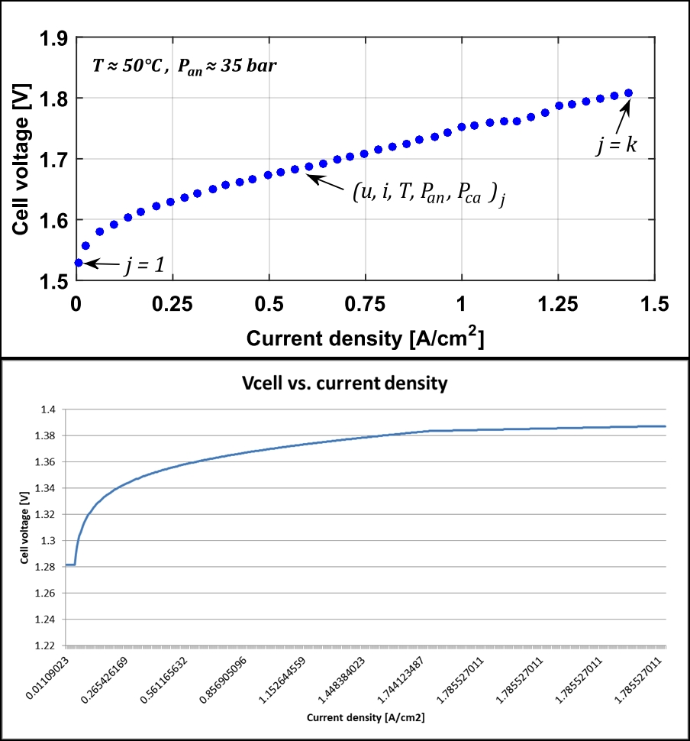

Fig.11.Electrolyser characterstic comparison with reference model

### Power-to-Heat

Heat pump model supplying district heating demand with constant temperature thermal storage tank will be modelled similar to Power-to-Gas model.

#### **Heat Pump Model:**

**Simple model:** linearized equations   
**Detailed model:** first order dynamics

### Electrical Base Load

Connected in PandaPower, as illustrated in Fig.6, to represent the constant base load in the industrial area.

# Co-Simulation Scenarios

## First case

To determine the holding duration for providing flexibility, plot the “active power demand/generation at bus3 vs. time” without any flexibility. Plot the same figure in all cases in order to investigate the effect of flexibility on active power balance.

## Second case

To investigate the hidden flexibilities, compare the amount of flexibility provided at nominal power set value for different Electrolyser models for same holding time decided in case 1. Do the same for heat pump model.

## Third case

To investigate the effect of hierarchical control on flexibility, add CEMS to the combined (P2H & P2G) system and measure the amount of flexibility for P2G & P2H.

# Inıtial Results

Fig.12 illustrates an overload initialization of wind turbine generator model for 300s with 600 intervals. Active power starts at 1.3 p.u. and stabilizes at 1 p.u after 10s. Reactive power, oscillates between ±0.5 p.u and reaches limit values when step increase occurs at the terminal bus voltage.

Shaft acceleration at the initialization can be observed as the oscillation in active power.

Open loop control responds to large disturbances such as abrupt active power increases. At initialization, and during the voltage step increase at 40, a condition occurs where active and reactive power cannot both be satisfied without violation of current limit. In this case, converter control gives priority to the reactive current, as can be observed with linear active power decrease.

Power factor controller, that maintains the nominal power factor and forces reactive power to follow active power changes, must be adjusted since it is unable to stabilize reactive power at “0MVar”. Closed loop voltage regulation control responds to step voltage increase at 40s by increasing the magnitude of the reactive power oscillations.

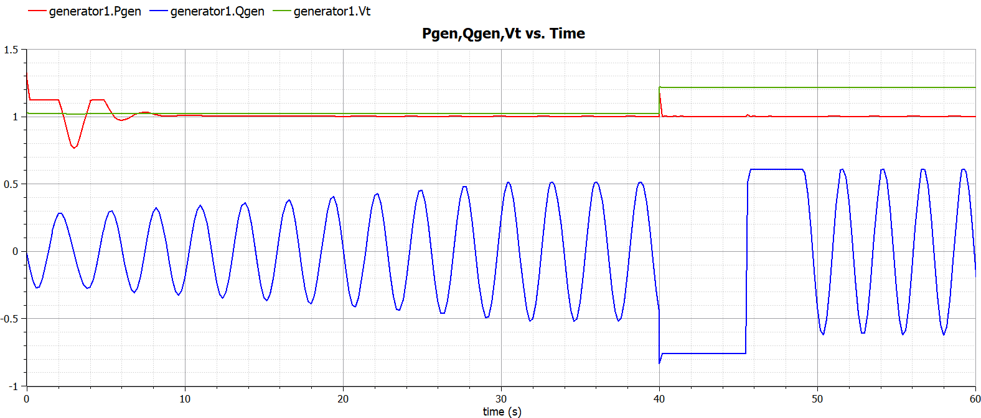

Fig.12 Wind Farm model response for 1.3MW PWF,OPF initialization and Vpcc step increase at 40s

Fig.13 shows the response of P2G system to ramp increase in tank pressure set value between 10-60s and step increase at PCC bus voltage at 90s. Active power first order response to new set value and active and reactive power response the PCC voltage step increase can be observed.

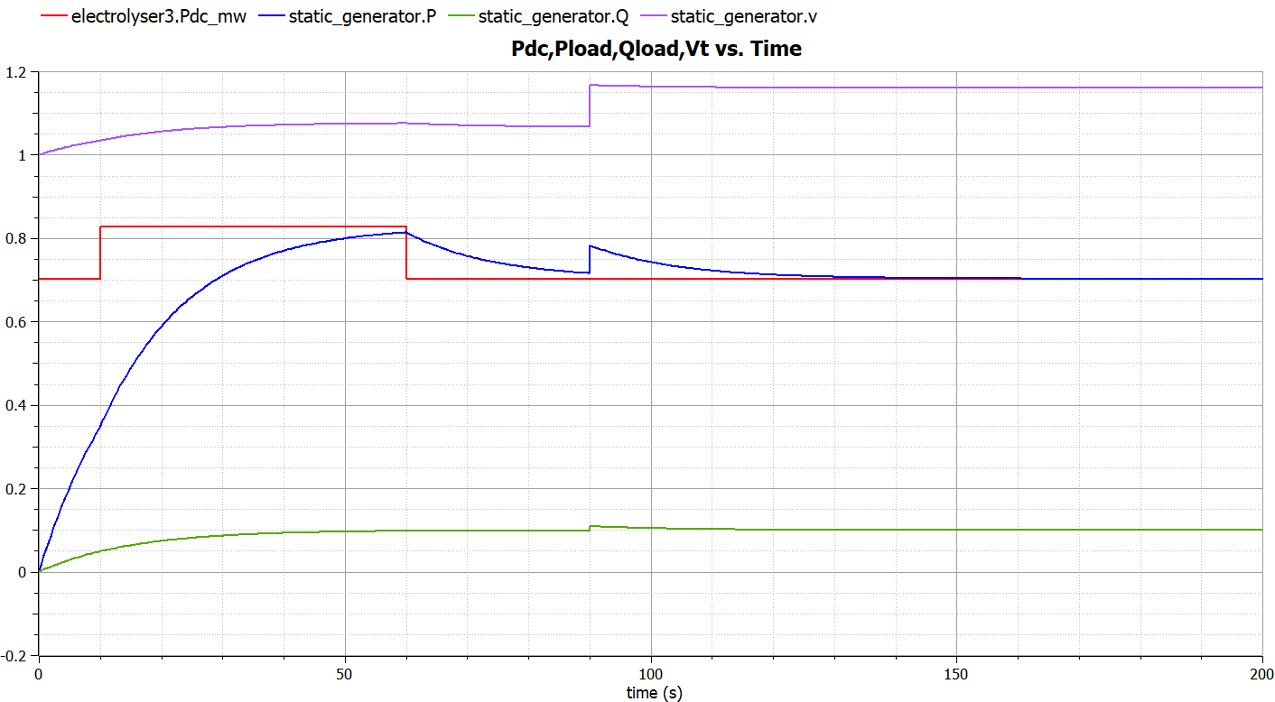

Fig.13 Power2Gas model response for Ptank,set ramp increase at 10-60s and Vpcc step increase at 90s

The controller of the PV Farm model currently gives error during compilation due to Vdc voltage drop to 0V at 8s, it will be corrected soon.

# Future Plans

#### **PV farm.fmu and P2H.fmu models**

These two OM models still need to be finalized in order to be used in co-simulation.

#### **Create input data (Demand profiles & Price signals)**

Industrial load profiles for hydrogen flow rate and heat flow rate, as well as, the intraday energy market price signals must be created for realistic results.

* + - 1. **Combine models in Energysim for co-simulation**Models (FMUs) need to be validated during co-simulation.

#### **Add losses and ambient temperature connector “heatport”**

Transmission losses are particularly important for curtailment discussions. Equipment (Electrolyser, Heat Pump, Storage) thermal/static/dynamic losses are important for demand side flexibility discussions. Therefore, it is important to add such dynamics into the models and observe their effects on flexibility results.

#### **Resolution of weather data**

Currently, windspeed and solar irradiation historical data is hourly from Renewables Ninja [2]. However, Koninklijke Nederlandse Meteorologisch Instituut(KNMI) Dataset [3], offers resolution of every 10 minutes for the same location. Therefore, resolution of data can be increased.

**References**

[1] P. D. Lund, J. Lindgren, J. Mikkola, and J. Salpakari, “Review of energy system flexibility measures to enable high levels of variable renewable electricity,” Renew. Sustain. Energy Rev., vol. 45, pp. 785–807, 2015.

[2] Renewables.ninja. 2020. Renewables.Ninja. [online] Available at: <https://www.renewables.ninja/> [Accessed 12 May 2020].

[3] Data.knmi.nl. 2020. KNMI Datacentre. [online] Available at: <https://data.knmi.nl/datasets> [Accessed 12 May 2020].

[4] Port of Rotterdam. 2020. Renewable Energy. [online] Available at: <https://www.portofrotterdam.com/en/renewable-energy> [Accessed 12 May 2020].

[5] Celsius Initiative. 2020. Industrial Residual Heat And Transmission In Leiden, Netherlands - Celsius Initiative. [online] Available at: <https://celsiuscity.eu/industrial-residual-heat-and-transmission-in-leiden-netherlands/> [Accessed 12 May 2020].

[6] Port of Rotterdam. 2020. Port Authority: Towards Larger-Scale Hydrogen Production And Network. [online] Available at: <https://www.portofrotterdam.com/en/news-and-press-releases/port-authority-towards-larger-scale-hydrogen-production-and-network> [Accessed 12 May 2020].

[7] Haven van Rotterdam. 2020. Zon Op De Slufter: Exploitant Gezocht Voor Grootste Drijvende Zonnepark Van Nederland. [online] Available at: <https://www.portofrotterdam.com/nl/nieuws-en-persberichten/zon-op-de-slufter> [Accessed 12 May 2020].

[8] L. Thurner, A. Scheidler, F. Schäfer et al, pandapower - an Open Source Python Tool for Convenient Modeling, Analysis and Optimization of Electric Power Systems, in IEEE Transactions on Power Systems, vol. 33, no. 6, pp. 6510-6521, Nov. 2018.

[9] M. Espinosa-López et al., “Modelling and experimental validation of a 46 kW PEM high pressure water electrolyzer,” Renew. Energy, vol. 119, pp. 160–173, 2018.

[10] J. Webster and C. Bode, “Implementation of a Non-Discretized Multiphysics PEM Electrolyzer Model in Modelica,” Proc. 13th Int. Model. Conf. Regensburg, Ger. March 4–6, 2019, vol. 157, pp. 833–840, 2019.

[11] G. Migoni, P. Rullo, F. Bergero, and E. Kofman, “Efficient simulation of Hybrid Renewable Energy Systems,” Int. J. Hydrogen Energy, vol. 41, no. 32, pp. 13934–13949, 2016.

[12] N. W. Miller, J. J. Sanchez-Gasca, W. W. Price, and R. W. Delmerico, “Dynamic modeling of GE 1.5 and 3.6 MW wind turbine-generators for stability simulations,” 2003 IEEE Power Eng. Soc. Gen. Meet. Conf. Proc., vol. 3, no. July, pp. 1977–1983, 2003.

[13] M. G. Villalva, J. R. Gazoli, and E. R. Filho, “Comprehensive approach to modeling and simulation of photovoltaic arrays,” IEEE Trans. Power Electron., vol. 24, no. 5, pp. 1198–1208, 2009.

[14] L. Vanfretti, T. Rabuzin, M. Baudette, and M. Murad, iTesla Power Systems Library (iPSL): A Modelica library for phasor time-domain simulations, SoftwareX, Available online 18 May 2016, ISSN 2352-7110, DOI: 10.1016/j.softx.2016.05.001.

[15] P. Schott, J. Sedlmeir, N. Strobel, T. Weber, G. Fridgen, and E. Abele, “A generic data model for describing flexibility in power markets,” Energies, vol. 12, no. 10, pp. 1–29, 2019.

[16] Raulrpearson.github.io. 2020. Pvsystems. [online] Available at: <https://raulrpearson.github.io/PVSystems/> [Accessed 13 May 2020].

[17] Gusain, D, Cvetković, M & Palensky, P 2019, Energy flexibility analysis using FMUWorld. in 2019 IEEE Milan PowerTech., 8810433, IEEE, 2019 IEEE Milan PowerTech, PowerTech 2019, Milan, Italy, 23/06/19. <https://doi.org/10.1109/PTC.2019.8810433>

[18] P. Olivier, C. Bourasseau, and P. B. Bouamama, “Low-temperature electrolysis system modelling: A review,” Renew. Sustain. Energy Rev., vol. 78, no. February, pp. 280–300, 2017.

[19] K. E. Hagan, O. O. Oyebanjo, T. M. Masaud, and R. Challoo, “A probabilistic forecasting model for accurate estimation of PV solar and wind power generation,” 2016 IEEE Power Energy Conf. Illinois, PECI 2016, pp. 1–5, 2016.

[20] P. Dubucq and G. Ackermann, “Frequency control in coupled energy systems with high penetration of renewable energies,” 5th Int. Conf. Clean Electr. Power Renew. Energy Resour. Impact, ICCEP 2015, pp. 326–332, 2015.

[21] V. H. Bui, A. Hussain, and H. M. Kim, “A multiagent-based hierarchical energy management strategy for multi-microgrids considering adjustable power and demand response,” IEEE Trans. Smart Grid, vol. 9, no. 2, pp. 1323–1333, 2018.

[22] C. Bode and G. Schmitz, “Dynamic simulation and comparison of different configurations for a coupled energy system with 100% renewables,” Energy Procedia, vol. 155, pp. 412–430, 2018.

[23] G. M. D. First, “Modelica TM - A Unified Object-Oriented Language for Physical Systems Modeling TUTORIAL and RATIONALE,” Design, pp. 1–49, 1999.

[24] Modelica Association, 2018. Modelica and the Modelica Association. URL: <https://www.modelica.org/>

[25] F. Bühler, F. M. Holm, and B. Elmegaard, “Potentials for the electrification of industrial processes in Denmark,” ECOS 2019 - Proc. 32nd Int. Conf. Effic. Cost, Optim. Simul. Environ. Impact Energy Syst., no. October, pp. 2137–2152, 2019.

[26] H. Wiertzema, M. Åhman, and S. Harvey, “Bottom-up methodology for assessing electrification options for deep decarbonisation of industrial processes,” Eceee Ind. Summer Study Proc., vol. 2018-June, pp. 389–397, 2018.

[27] P. Palensky and D. Dietrich, “Demand side management: Demand response, intelligent energy systems, and smart loads,” IEEE Trans. Ind. Informatics, vol. 7, no. 3, pp. 381–388, 2011.